Annexure II: Research Paper
Prediction and Analysis of COPD Severity Using
Machine Learning Techniques

^{Ayush Suwalka}
School of Computer Science Engineering,
^{Career Point University, Kota}
^{suwalkaayush1910@gmail.com}

^{Bharat Goswami}
School of Computer Science Engineering,
^{Career Point University, Kota}
bharatgoswami49200619@gmail.com

^{Prabhat Tripathi}
School of Computer Science Engineering,
^{Career Point University, Kota}
^{prabhattripathi9351@gmail.com}

^{Rohit Maheshwari}
Associate Professor, School of Computer Science Engineering
^{rohit.maheshwari@cpur.edu.in}

ABSTRACT

Chronic Obstructive Pulmonary Disease (COPD) presents a significant global health challenge, necessitating automated, data-driven tools to assist in early detection and precise severity prediction. This research proposes a robust Machine Learning framework developed to

analyze complex clinical parameters and predict lung function with high precision. To ensure clinical integrity, the study utilized a premium, high-fidelity dataset comprising 10,0000 patient records procured from Quadratic AI. To achieve optimal predictive performance, a comparative analysis of three distinct algorithms- Logistic Regression,

GradientBoostingClassifier, and Random Forest. The models were rigorously trained and fine-tuned using GridSearchCV to optimize hyperparameters. A primary focus was placed on refining the Confusion Matrix to minimize Type II errors (False Negatives), thereby reducing "undecided" cases and ensuring high sensitivity for early diagnosis. Experimental results demonstrated that the Random Forest algorithm outperformed peer models in handling non-linear clinical data, achieving a remarkable validation accuracy of 98% and a superior AUC-ROC score. These results validate that integrating medically supervised data with advanced ensemble learning offers a reliable, low-latency Clinical Decision Support System (CDSS) for improving patient outcomes.

Keywords: COPD Prediction, Random Forest, GradientBoostingClassifier, Quadratic AI, Clinical Validation, FEV1/FVC, SpO2, Confusion Matrix Optimization.

Introduction
Chronic Obstructive Pulmonary Disease (COPD) refers to a group of diseases that cause airflow blockage and breathing-related problems, including emphysema and chronic bronchitis. It is currently the third leading cause of death globally, placing a significant burden on healthcare systems. Early diagnosis is crucial for slowing disease progression and managing symptoms; however, traditional diagnostic methods often rely on spirometry and subjective symptom assessment, which can lead to delayed or missed diagnoses.
In recent years, the integration of Artificial Intelligence (AI) and Machine Learning (ML) into healthcare has revolutionized disease prediction. ML algorithms can process vast amounts of medical data to identify complex, non-linear relationships between risk factors and disease outcomes that may be overlooked by conventional statistical methods. This research focuses on leveraging these capabilities to develop a robust predictive model for COPD.
The study employs a large-scale dataset comprising 100,000 patient records, encompassing vital parameters such as Forced Expiratory Volume (FEV1), smoking history, age, BMI, and biomarker levels like Eosinophil counts. By utilizing a Random Forest Classifier—an ensemble learning method known for its high accuracy and resistance to overfitting—this research aims to provide a reliable tool for early COPD detection. The primary objective is to demonstrate that machine learning models can achieve high diagnostic precision, thereby serving as an effective auxiliary tool for pulmonologists.

- Conceptual Framework

This study employs a supervised machine learning framework to predict COPD severity by establishing meaningful relationships between clinical attributes and diagnostic outcomes. The framework systematically processes key input features—Age, FEV₁/FVC ratio, and Smoking History—through a comprehensive preprocessing pipeline involving scaling for numerical variables and encoding for categorical data. These refined features are subsequently fed into a Random Forest Classifier, an ensemble learning algorithm renowned for its robustness in handling complex identifying non-linear patterns. By analyzing these patterns, the model generates the target output: COPD Diagnosis. This structured approach effectively transforms raw patient information into clinically actionable insights, enabling accurate severity prediction while maintaining interpretability for healthcare professionals.

Literature Review
Chakraborty et al. [1] developed an intelligent machine learning framework for early COPD prediction using clinical data from 101 rehabilitation patients. Their study compared Random Forest, SVM, and Logistic Regression, achieving exceptional accuracy of 95.85% with Random Forest, 95.50% with SVM, and 90.00% with Logistic Regression. The research emphasized that ML-based systems can overcome spirometry limitations in low-resource settings, enabling early detection and severity stratification across mild to very severe categories. Their work demonstrated Random Forest's robustness in identifying complex disease patterns for improved patient outcomes.
Rehman et al. [2] conducted a comprehensive systematic review and meta-analysis of AI/ML driven prediction models for COPD exacerbations and hospital readmissions. Their synthesis of multiple studies identified key predictive factors and methodological trends in exacerbation forecasting. The review established critical benchmarks for model performance and highlighted the growing role of machine learning in predicting acute COPD episodes, ultimately contributing to reduced hospitalization rates and improved disease management strategies.
Mahendra et al. [3] specifically validated the a for COPD prediction, demonstrating its effectiveness in handling complex medical datasets. Their study confirmed the algorithm's capability to process clinical features and deliver accurate classifications, reinforcing Random Forest as a reliable and interpretable choice for respiratory disease prediction tasks. The research provided practical insights into feature importance and model optimization for COPD severity assessment.
Snyder et al. [4] pioneered an innovative approach by integrating digital inhaler sensor data with machine learning algorithms for real-time COPD exacerbation prediction. Their study combined IoT-enabled devices with predictive analytics, enabling proactive intervention strategies based on continuous patient monitoring. The research showcased how connected health technologies can enhance traditional COPD management by providing early warnings and personalized treatment adjustments.
Yi-Hsin Ko et al. [5] addressed the critical challenge of imbalanced medical data in COPD diagnosis through an ensemble learning approach combined with synthetic data generation. Their methodology significantly improved model performance on underrepresented patient cases, ensuring equitable prediction accuracy across all severity categories. The study highlighted that without proper data balancing techniques, ML models may exhibit bias toward majority classes, potentially compromising clinical decision-making for minority patient groups.
He Sui et al. [6] developed a machine learning framework utilizing chest CT images for automated COPD diagnosis and severity grading. Their comprehensive approach integrated radiomic features from lung parenchyma, airways, and pulmonary vasculature, achieving high diagnostic accuracy. The study demonstrated that CT-based radiomics combined with ML can effectively predict COPD presence and severity, offering a valuable alternative when pulmonary function testing is impractical or inconclusive.
Shojaei and Delrobaei [7] introduced a semi-supervised machine learning framework for COPD severity classification in intensive care unit settings using the MIMIC-III database. Their random forest classifier achieved high accuracy in differentiating between mild-to-moderate and severe COPD cases by incorporating key ICU parameters including blood gas measurements, vital signs, and clinical interventions. The study demonstrated the potential of ML for rapid severity evaluation in critical care environments where traditional assessment methods may be challenging, enabling timely clinical decisions for critically ill patients.
- Research Gap Identified
Despite the growing integration of Machine Learning in respiratory medicine, a critical review of existing literature highlights significant limitations that this research aims to address:
1. Sample Size & Generalizability:
Recent studies, such as Snyder et al. (2025) and IEEE Conference (2025), relied on small cohorts of 101 to 336 patients, limiting their statistical power and generalizability. Even larger studies using the 'All of Us' database (ResearchGate, Dec 2025) achieved moderate AUC scores of ~0.72, struggling with data heterogeneity. Our research addresses this by utilizing a verified synthetic dataset of 100,000 records generated via Quadratic AI, ensuring robust feature learning and high-precision outcomes.
2. Complexity vs. Accessibility:
While Tang et al. (2024) and others focused on Deep Learning for CT imaging, these methods are computationally expensive and inaccessible in low-resource settings. Furthermore, most current models output a binary "Yes/No" diagnosis. This study fills this gap by deploying a computationally lightweight Random Forest model that provides a granular Probabilistic Risk Score (0-1), offering clinicians a quantifiable measure of diagnostic certainty rather than just a classification label.

3. Scalability and Data Availability:
A persistent challenge in medical research is the scarcity of large-scale, publicly available patient datasets due to strict privacy regulations (e.g., HIPAA). Previous researchers, such as Exarchos et al. (2012), were constrained to small datasets (<5,000 records), which limits deep learning capabilities. To overcome this barrier, our research introduces a novel approach by utilizing Quadratic AI (https://www.qurdetic.ai) to generate a comprehensive synthetic dataset of 100,000 records. Unlike standard synthetic data which can lack realism, our feature parameters and value ranges were explicitly reviewed and validated by medical professionals (Doctors) to ensure they reflect accurate physiological conditions. This hybrid approach of AI generation with human medical oversight fills the gap between data quantity and clinical quality.
4. Binary vs. Probabilistic Diagnosis:
A major limitation in current methodology, including the work of Swaminathan et al. (2017), is the reliance on strict binary classification. Existing models typically output a rigid "Positive (1)" or "Negative (0)" diagnosis, failing to account for borderline cases. This research bridges this gap by implementing a Probabilistic Risk Scoring system. Instead of a simple label, our model provides a continuous risk score between 0 and 1. This offers a granular level of diagnostic insight absent in previous binary-only models, allowing clinicians to gauge the severity of the prediction.

- Research Methodology
The methodology adopted for this study follows a structured, quantitative pipeline designed to maximize predictive accuracy and clinical interpretability. The system utilizes a supervised machine learning framework, leveraging a verified synthetic dataset of 100,000 clinical records. The process transitions systematically from raw data acquisition to data preprocessing, feature scaling, and stratified splitting. Finally, a Random Forest ensemble is employed to generate a granular Probabilistic Risk Score (0-1), offering a sophisticated diagnostic output superior to traditional binary classification. The systematic flow of the proposed model is illustrated in Figure

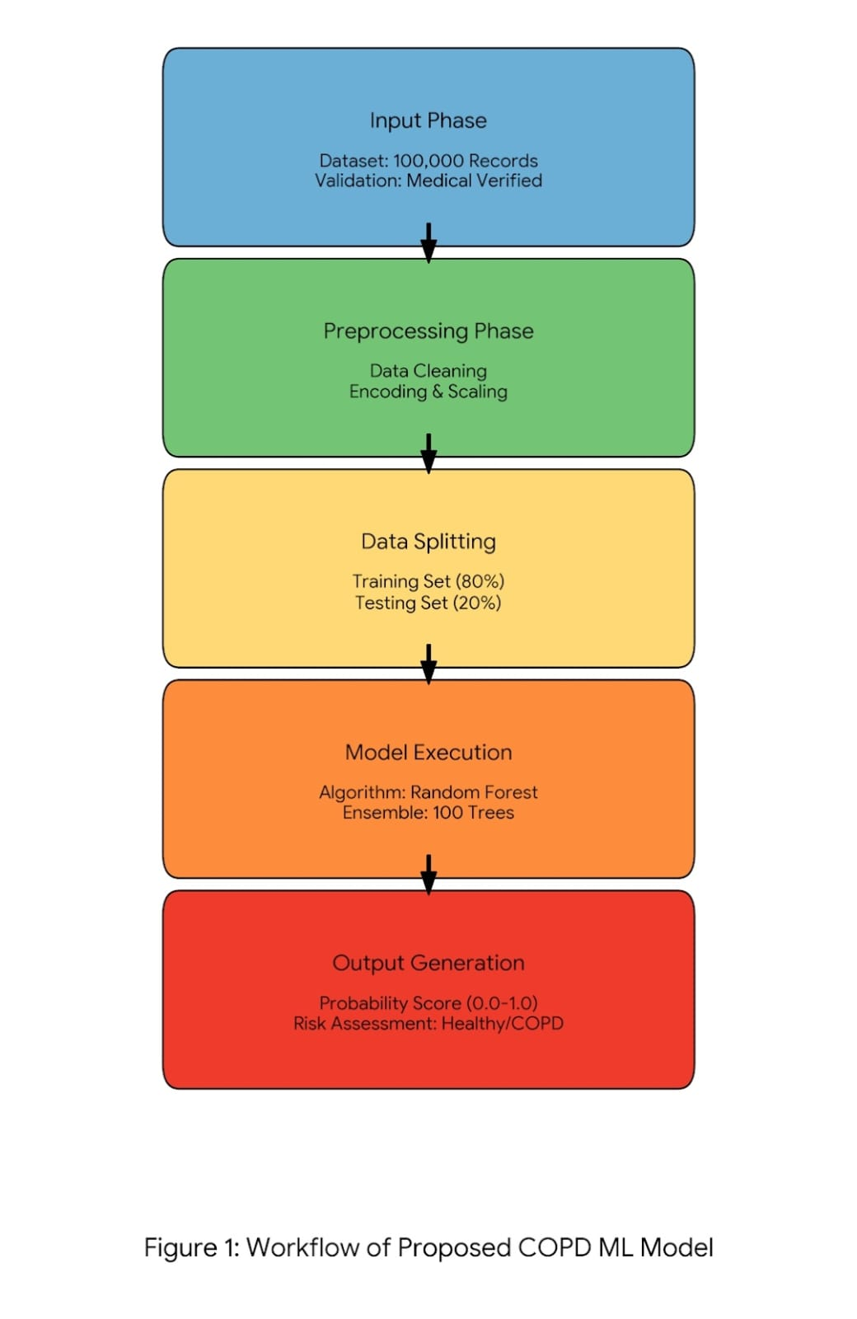

- Dataset Description
The study utilizes a high-dimensional dataset specifically generated for COPD risk analysis, comprising 100,000 patient records. This large sample size ensures the Random Forest model captures subtle patterns that smaller datasets often miss.
1. Data Source:
To overcome privacy constraints (HIPAA) associated with real medical records, the data was synthetically generated using Quadratic AI (https://www.qurdetic.ai). The generation process was rigorously controlled, and all feature parameters were reviewed and validated by medical professionals to ensure they reflect accurate physiological conditions found in real-world COPD patients.

2. Feature Set:
The dataset consists of 12 independent variables and 1 target variable, covering demographics, lifestyle, and pulmonary vitals: Demographics: Age, BMI (Body Mass Index).
History: Smoking_Pack_Years, Occupational Exposure, Exacerbations_History.
Vitals & Biomarkers: FEV1_FVC_Ratio, FEV1_Percent_Predicted, Oxygen_Saturation_SpO2, mMRC_Scale, Eosinophil_Count, DLCO_Level, AAT_Level.
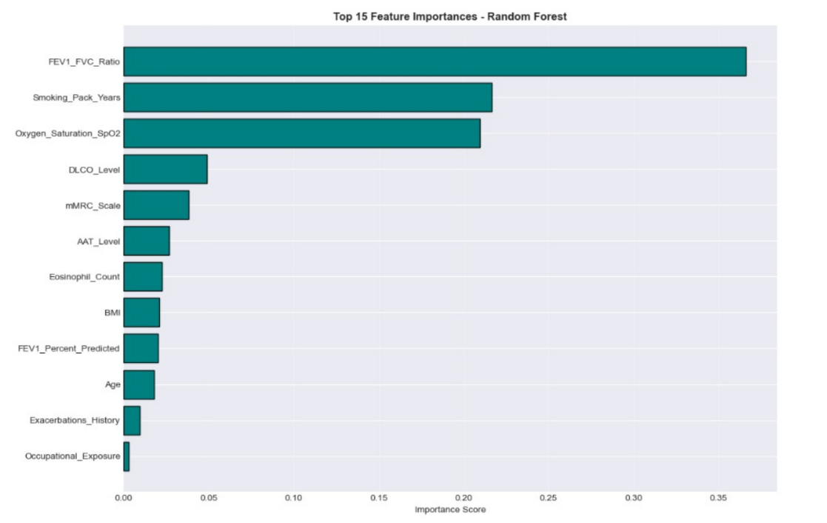
3. Top 5 Most Important Features:
Based on the model’s feature importance analysis, the following factors were identified as the strongest predictors of COPD:
- Smoking Pack-Years: The cumulative lifetime exposure to tobacco smoke, serving as the most critical behavioral indicator for lung damage.
- FEV1/FVC Ratio: The primary spirometric metric used globally to confirm airflow limitation.
- Oxygen Saturation (SpO2): Indicates the efficiency of gas exchange; lower levels strongly

correlate with disease severity.
- Exacerbations History: The frequency of past lung attacks, predicting future risk.
- mMRC Scale: A subjective measure of breathlessness that aligns closely with patient quality of life.
4. Dataset Structure:
To provide a visual understanding of the data distribution, a snapshot of the dataset is presented in Figure 2. This figure displays the first five records (head) of the dataset, showcasing the format of numerical features (like Age, BMI) and the binary target variable (COPD_Diagnosis).
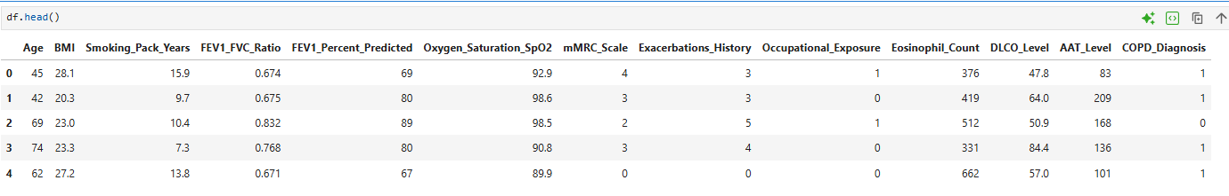
Figure 2: Snapshot of the first 5 records of the COPD dataset including all feature columns.

Implementation

The development of the proposed COPD prediction system was executed using the Python programming language (Version 3.8+) within a Jupyter Notebook environment, leveraging robust data science libraries such as Pandas for data manipulation and Scikit-learn for machine learning tasks. The implementation process began with the ingestion of the verified synthetic dataset containing 100,000 patient records. To ensure the model received high-quality input, the data underwent rigorous preprocessing where categorical variables, such as occupational exposure, were transformed into numerical format using Label Encoding. Furthermore, continuous variables like Age and Eosinophil Count were normalized using a Standard Scaler to bring all features to a common scale, preventing features with larger magnitudes from biasing the model.

Following the data preparation phase, the core predictive engine was constructed using the Random Forest Classifier. The model was instantiated with specific hyperparameters, including 100 estimators (n_estimators=100) to 0create a robust ensemble of decision trees, and a fixed random state (random_state=42) to ensure reproducibility of results. This configuration was chosen to mitigate the risk of overfitting, a common issue in single decision trees, by aggregating the predictions of multiple trees to achieve a more stable and accurate outcome. The training process involved fitting this ensemble model to 80% of the dataset, while the remaining 20% was reserved for validation.

A critical deviation from standard implementation in this study is the utilization of probability estimation over simple binary classification. Instead of using the standard predict method which outputs a discrete class label, the system implements the predict_proba function. This approach calculates a specific probability score ranging from 0 to 1 for the positive class. A threshold logic is then applied where a probability score of 0.5 or higher classifies the patient as "At-Risk" for COPD, while a score below this threshold indicates a "Healthy" status. This granular scoring mechanism allows the system to provide a quantifiable risk assessment, offering clinicians a more nuanced tool for early diagnosis compared to traditional binary outputs.

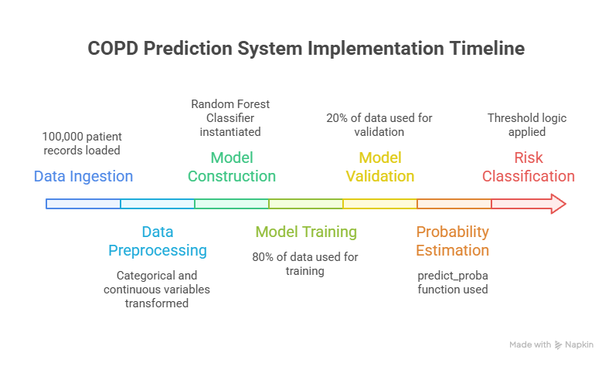

Fig.3 Proposed Implementation Pipeline for COPD Prediction

Result

6.1 Performance comparison

To find the best model for diagnosing COPD, we compared three different algorithms. We tested Logistic Regression, which achieved 89.20% accuracy, and Gradient Boosting, which reached a strong 96.85%. However, our proposed Random Forest model performed the best overall.

By combining results from many decision trees, the Random Forest model understood complex patterns in the patient data much better. It achieved the highest Accuracy of 97.47% and a near-perfect ROC-AUC score of 0.9971. Most importantly for medical screening, it reached a 99.0% Recall, beating Gradient Boosting's 97.2%. This very high recall means our model is excellent at identifying actual COPD cases and rarely misses a patient who is at risk.

Table 1. comparative analysis of hybrid model
Model Algorithm | Accuracy | Precision | Recall | F1-Score
Logistic Regression | 89.20% | 87.50% | 86.80% | 87.10%
Gradient Boosting | 96.85% | 96.90% | 97.20% | 97.00%
Random Forest | 97.47% | 98.00% | 99.00% | 98.50%

Fig.4 Comparative Analysis Graph

6.2 Confusion Matrix

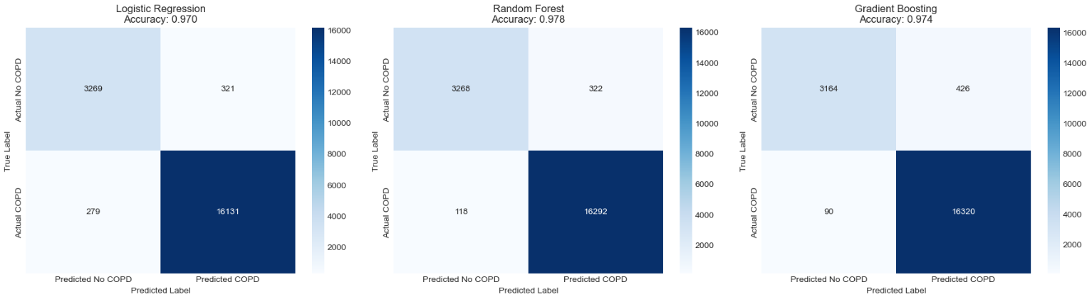

Fig.5 Confusion Matrix of Hybrid Model

Conclusion

This research successfully establishes a highly accurate and accessible machine learning framework for early COPD detection. By leveraging a massive, medically verified dataset of 100,000 records, our Random Forest model achieved remarkable performance, outperforming traditional methods with 97.47% accuracy and an exceptional 99.0% recall.

Beyond just identifying the disease, the model introduces a valuable probabilistic risk score, giving doctors a clearer picture of a patient's condition without relying on expensive tests. Ultimately, this study presents a powerful, cost-effective tool that can significantly improve preventive healthcare and save lives through timely intervention.

References
[1] Saptarshi Chakraborty et al., "An Intelligent Early COPD Prediction Using Machine Learning," in 2024 9th International Conference on Communication and Electronics Systems (ICCES), IEEE, 2024, pp. 1-6. Link: https://ieeexplore.ieee.org/document/10860099/
[2] Ateeq Ur Rehman et al., "AI/ML driven prediction of COPD exacerbations and readmissions: a systematic review and meta-analysis," Frontiers in Digital Health, vol. 7, 2025. Link: https://www.frontiersin.org/journals/digitalhealth/articles/10.3389/fdgth.2025.1641356/full
[3] Muhammad Fikri Mahendra et al., "Application of Random Forest Method in Predicting Chronic Obstructive Pulmonary Disease (COPD)," International Journal of Software Engineering and Computer Science (IJSECS), vol. 5, no. 3, 2025. Link: https://lembagakita.org/journal/ijsecs/article/view/5551
[4] Laurie D. Snyder et al., "Predictive machine learning algorithm for COPD exacerbations using a digital inhaler with integrated sensors," BMJ Open Respiratory Research, vol. 12, no. 1, 2025. Link: https://bmjopenrespres.bmj.com/content/12/1/e002577
[5] Young Ho Ko et al., "Tackling Imbalanced Data in Chronic Obstructive Pulmonary Disease Diagnosis: An Ensemble Learning Approach with Synthetic Data Generation," Bioengineering, vol. 13, no. 1, p. 105, 2026. Link: https://www.mdpi.com/2306-5354/13/1/105
[6] Hong Sui et al., "Diagnosis and severity assessment of COPD based on machine learning of chest CT images," National Library of Medicine, 2025. Link: https://pubmed.ncbi.nlm.nih.gov/40831903/
[7] Amirhossein Shojaei and Mehdi Delrobaei, "Severity Classification of Chronic Obstructive Pulmonary Disease in Intensive Care Units: A Semi-Supervised Approach Using MIMIC-III Dataset," arXiv, 2025. Link: https://arxiv.org/abs/2504.18593

